‍‍Harish Harshan | UX Developer
B A-7, Gunina Linda Apt, Bannerghatta Road, Gottigere, Bangalore-560076 Mob ph: +918884086621 | Home: 080 4890 4735 | harryharshan41188@gmail.com
Objective
Experienced User Experience Developer with 8 years of demonstrated history working in the information technology and services industry. Skilled in Angular Web Applications, Responsive Web development, and User Experience Design & Development. Strong information technology professional with a Master of Science (MSc) focused in Computer Technology and likely to be in a position where my skills and potential could be put to the success and progress of the organization.
Professional Experience
UX Developer | smarsh previously actiance pvt ltd | currently working
- Individual contributor and only UX developer for the Organization
- Responsible for the UX development on angular application which is mainly based on Archiving
- Manual testing and Browser debugging (all browsers) for the app based on W3C standards
- SCSS unit test to ensure the styling will not break in any circumstances
  - Tools and Languages Used
    - HTML5, SCSS, Angular and Angular Material
    - VS Code, Marvel app, and InVision
UX Engineer | truckstop.com FOR calpion software technologies | apr 2018 to oct 2018
- Responsible for all UI/UX activities needed in Calpion in terms of websites, collateral design etc.
- Responsible for the UX development on Truckstop application, which focusses on broker-carrier transactions and bookings in USA
  - Tools and Languages Used
    - HTML5, CSS3, JQUERY and Angular Material
    - Photoshop and Illustrator
SENIOR ui/UX dEVELOPER | SCHNEIDER eLECTRIC FOR TEKSYSTEMS INC | nov 2017 to mar 2018
- Responsible for content management in Schneider’s internal portal “Offer Creation Portal”
- Created UI interactions for the Schneider’s frameworks and process using the below tools and programming languages
  - Tools and Languages Used
    - HTML5, CSS3, JQUERY and Java Script
SENIOR web dEVELOPER | lenovo india FOR blueocean | jun 2017 to sep 2017
- Responsible for “test & run” and “create” test cases for Lenovo and Moto products globally
- Target specific regions globally and analyze the product scope for better sales and customization through “A/B” test.
- Created different UI for pages based on customer interest and product scope for Lenovo and Moto using the below tools and programming languages
  - Tools and Languages Used
    - HTML5, CSS3, JS and “Rhino” JS
    - ADOBE TARGET for Analytics and Marketing Reports
ux engineer | productlabs solutions | jun 2016 to may 2017
- Responsible for UI/UX Design and Development for the HRM solution application “ESP”
- Been part of the mobile app development creating UI screens for the ESP platform
- Created the login API module with the technical team for “MyCampusDays”
  - Tools and Languages Used
    - HTML5, CSS3, Responsive CSS, Twitter Bootstrap, JQUERY and Java Script
    - PHP, MYSQL, XAMPP
    - Photoshop and Illustrator
Front-end developer | sasken technologies ltd | JULY 2014 to june 2016
- Responsible for maintaining SASKEN’s corporate website
- Created micro-sites (client specific), html mailers, Newsletters, event banners
- Created SASKEN’s intranet portal “i-KEN”
- Created Image portal for SASKEN “pic-stock”
  - Tools and Languages Used
    - HTML5, CSS3, Responsive CSS, Twitter Bootstrap, JQUERY and Java Script
    - Photoshop, Illustrator and Premier
Web developer | indegene lifesystems | Mar 2012 to july 2014
- Responsible for creating websites for leading medical companies such as GSK, RANBAXY, ALLERGAN, B+L, SANOFI, etc...
- Created iPAD i-details for ALLERGAN, PFIZER, FOREST, GSK, ASTRA ZENACA, etc... which runs on platforms such as JUWI, SKURA and VEEVA
  - Tools and Languages Used
    - HTML5, CSS3, Responsive CSS, Twitter Bootstrap, JQUERY and Java Script
    - Photoshop, Illustrator and Premier

Skills & Abilities
Key SKILLS | Area of interest  Web Application (Design and Dev)  Front End Design and Development  Multimedia
  HTML5  SCSS  CSS3  Responsive CSS | Angular (UX side)  Angular Material  Bootstrap,  JQUERY, Java Script

Tools I Use For Design and Development

  VS Code |   Photoshop |   Illustrator |   Marvel App |   InVision | 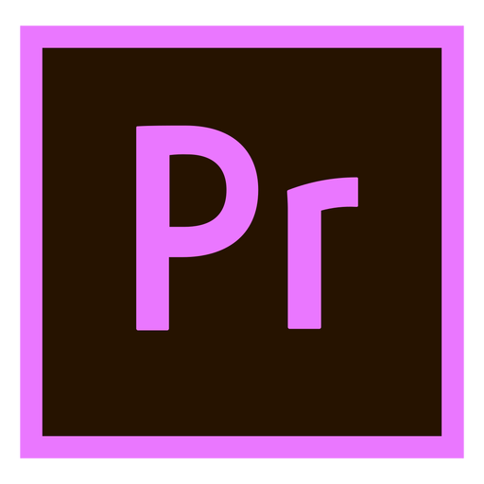  Premier |   Dreamweaver
Courses from Udemy
- User Experience Design Fundamentals
- UX, Web Design Master Course – Strategy, Design and Development
- Information Architecture - Fundamentals
Education
MSc | (JUN 2011) : Secured - 74% | NI College of Engineering
- Major: Computer Technology
H.S.C | | (APRIL 2006) : SECURED - 65.5% | Sree Vivekananda Matric Hr Sec School
- Major: Maths – Biology
S.S.L.C | (MAR 2004) : SECURED - 67% | Sree Vivekananda Matric Hr Sec School
- Major: Maths − Biology

Personal Profile
Name | : | Harish Harshan
Father’s Name | : | Harshan K
Sex | : | Male
Date of Birth | : | 04/11/1988
Nationality | : | Indian
Languages Known | : | English, Tamil, Hindi, Malayalam, Kannada
Blood Group | : | O+
LinkedIn | : | www.linkedin.com/in/harryharshan
Personal Web | : | https://harryharshan-1.firebaseapp.com/
Declaration
I hereby declare that the information furnished above is true to the best of my knowledge.
Date :
Place :
Signature :
Harish.H

